DOPPLER EFFECT

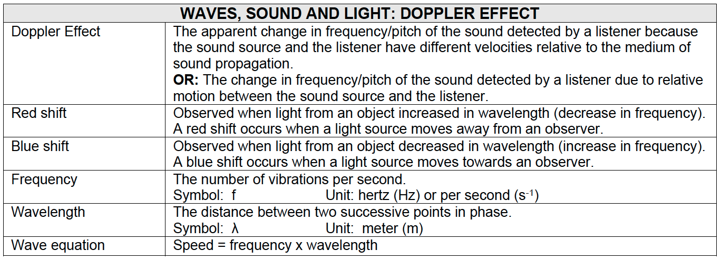

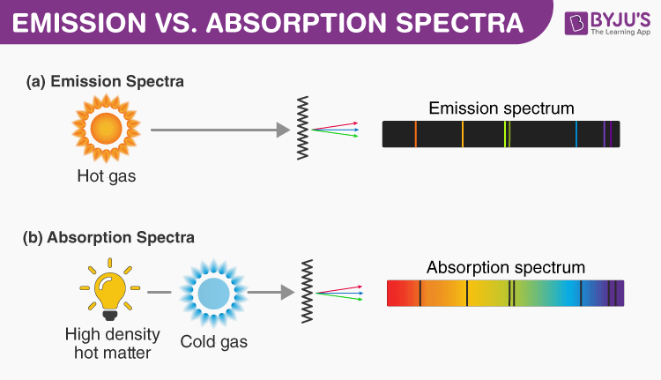

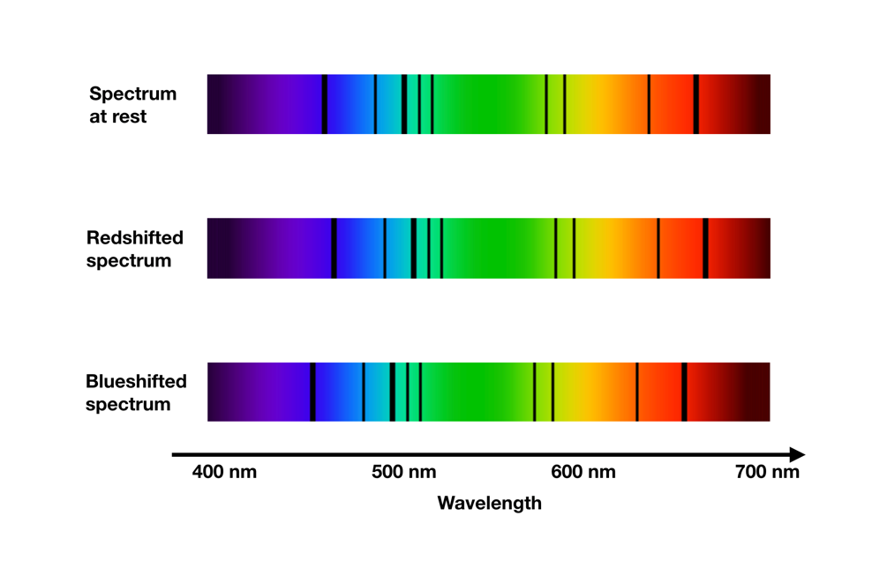

If a star moves AWAY from the observer, a lower frequency and longer wavelength is detected. The lower frequency or longer wavelength corresponds to the red end of the spectrum.

If two objects are approaching each other: v = fλ
The wavelengths become shorter (waves become more compressed). Since the speed of sound is constant, the observed frequency will therefor increase.
OR
For a constant speed of sound, the observed frequency increases because the number of wave fronts per second reaching the observer increase.

STRUCTURED QUESTIONS

